LOUIE BELLSON LEGACY .
An American Legend Catalog  Order Form
www.louiebellson.com

ITEM | DESCRIPTION | Qty | Price | Amount
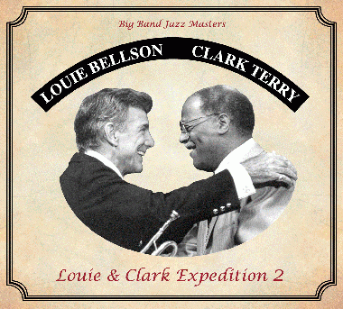 | CD: Louie & Clark Expedition 2  (Big Band)  Jazz Masters Louie Bellson and Clark Terry (trumpet).  Composed by Bellson, the album also features Kenny Washington and Sylvia Cuenca on drums. |  | $20
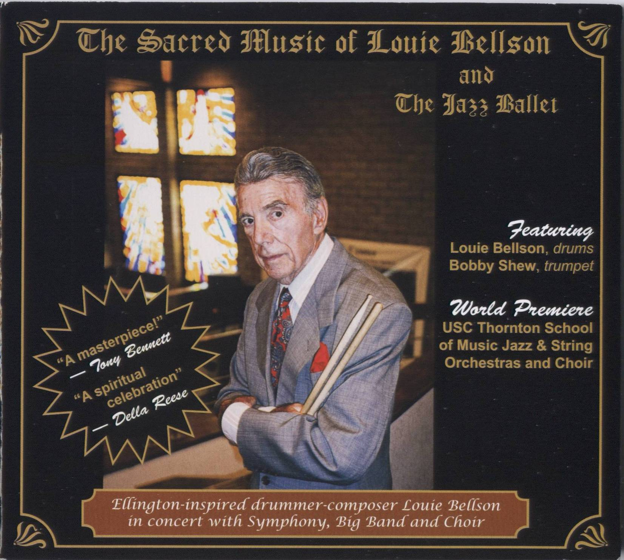 | CD: The Sacred Music of Louie Bellson  (Big Band, Symphony & Choir)  Composed/performed by Bellson & USC Thornton School, this CD has been hailed “a masterpiece” by Tony Bennett and “a spiritual celebration” by Della Reese. |  | $20
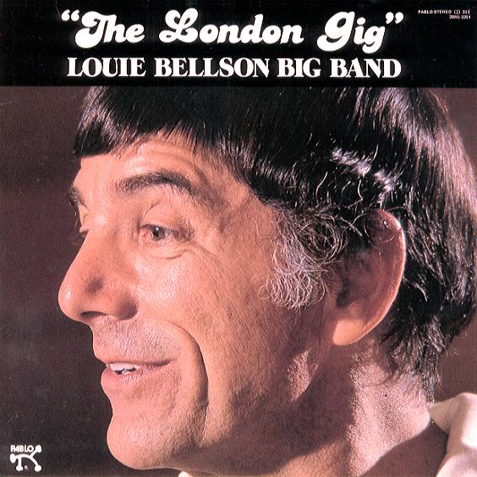  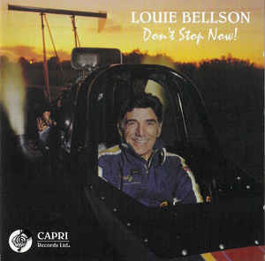  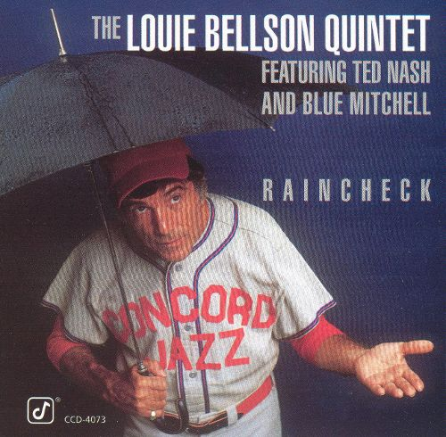 | CDs, Vintage Bellson  __ Don’t Stop Now! __ Airmail Special  __ Raincheck __ The London Gig  __ Louie Bellson Jam with Blue Mitchell  __ Pearl Bailey and Louie Bellson In New York |  | $15
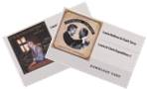  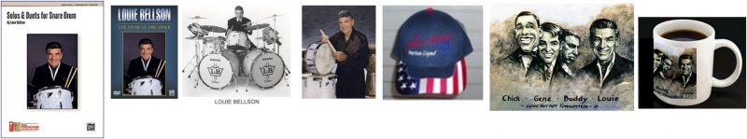 | DOWNLOAD CARD:  Download an entire Bellson album to your device.  (Tip - It makes a great gift enclosure in greeting cards, etc.)  ◻ “Louie & Clark Expedition 2”  ◻ “The Sacred Music of Louie Bellson” |  | $5
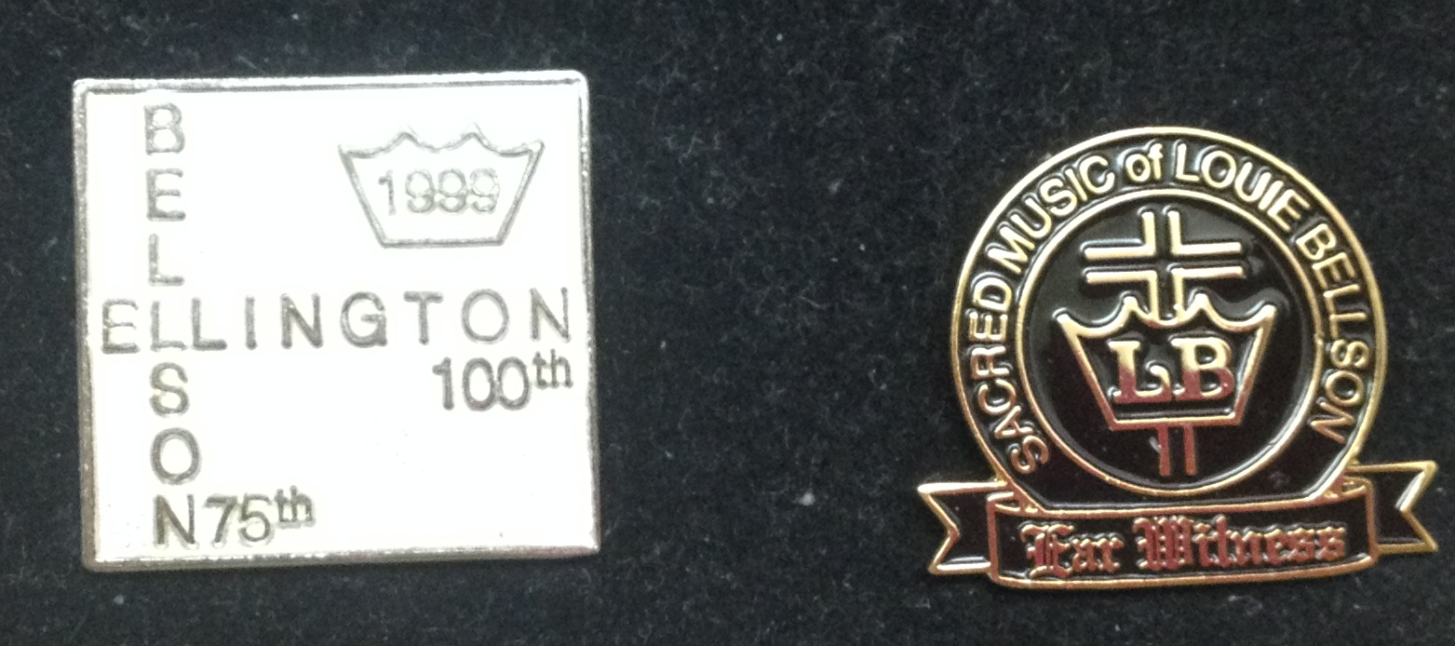 | BOOK: Solos & Duets for Snare Drum  A special collection of Medium to Medium-Difficult snare drum solos and duets. Written by the late jazz drumming legend Louie Bellson, the exclusive collection includes some of the last few snare drum solos he ever wrote. |  | $10
 | LAPEL PIN – Bellson 75th /Ellington 100th, 1999  silver, 1” x 1” ___  LAPEL PIN – Sacred Music of LB  black & gold, 1" x 7/8" ___ |  | $5  $5
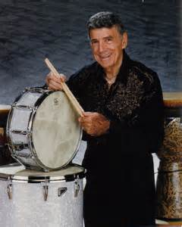 | PHOTO: b&w 8”x10”  (Pre-autographed) ___  PHOTO: color 8”x10”  (Pre-autographed) ___ |  | $5  $10
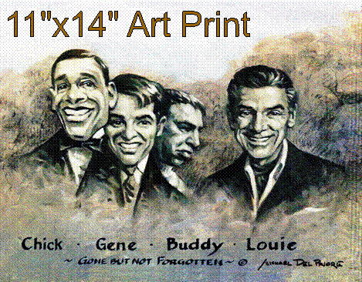 | ART PRINT: 11”x14” giclee on canvas, 4 drum legends. “Gone But Not Forgotten” by Michael DelPriore  This national award-winning portrait artist has painted more than 600 portraits in his 20-year career. His works are in many state capitols, supreme courts, universities, boardrooms and private collections. |  | $20
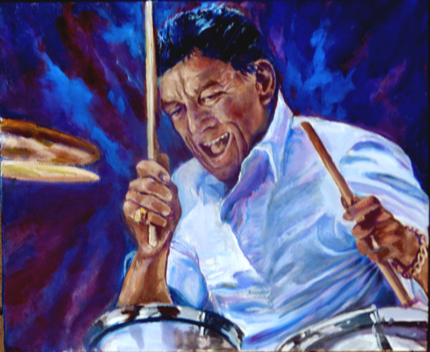  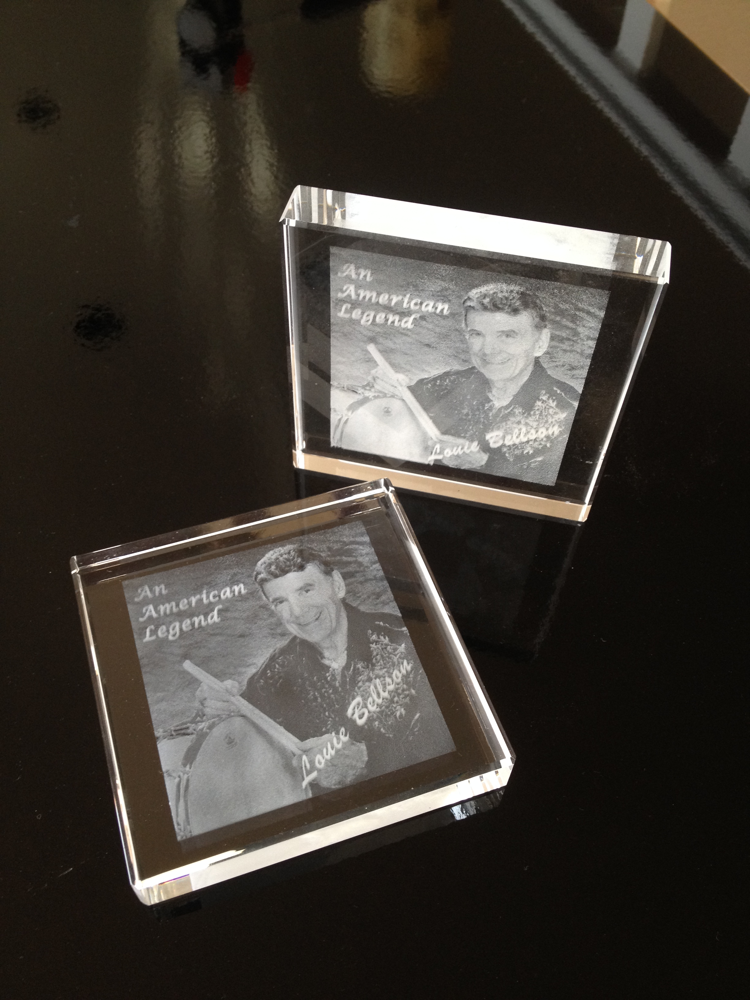 | ART PRINT: 8.5”x11” giclee of Louie Bellson in action  by Merryl Jaye  Ms. Jaye paints portraits of the jazz greats. Selected for their preeminence in their field, her subjects have been vividly rendered as she captures on canvas the emotion and spontaneity of jazz in live performance. |  | $20
 | CRYSTAL BLOCK: 3.5” x 3.5” x 5/8” thick  by Crystal Impressions®  Laser engraving in crystal clear optical glass  “An American Legend – Louie Bellson” w/ snare & sticks |  | $35
 | Total – Page 1 |  |  | $
To Order: Use Worksheet (p. 4)
p. 2

ITEM | DESCRIPTION | Qty | Price | Amount
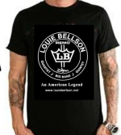  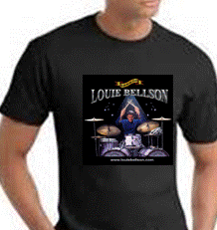 | ← T-SHIRT: Bellson band logo  __L __XL (men’s sizing) |  | $20
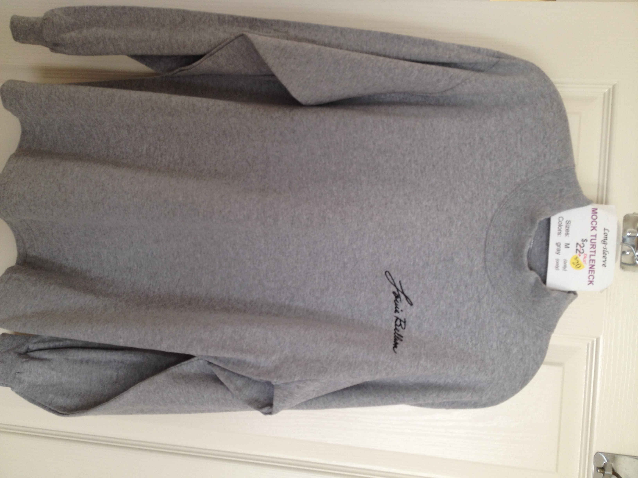 | ← T-SHIRT: full color design, LB playing drums.  __XL (men’s sizing)  (Hurry – only a few left!) |  | $25
 | MOCK TURTLENECK  (long-sleeve)  w/embroidered LB Autograph  __M (men’s sizing) |  | $25
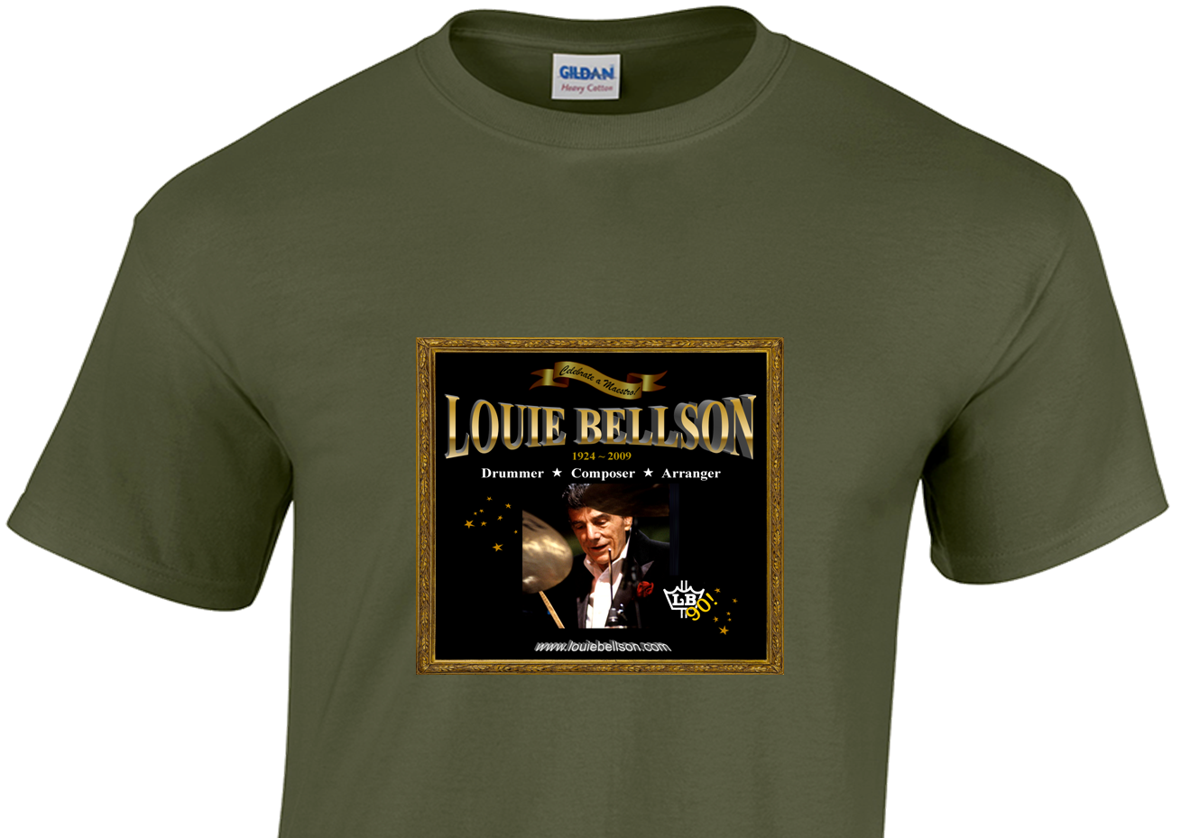 | T-SHIRT: LB 90 design, “Celebrate a Maestro!”  “Celebrating 90 years of Louie Bellson masterworks”    on military green shirt  __M __XL __2XL (men’s sizing)  ■ Instant Order: Sidebar of http://www.louiebellson.com |  | $20
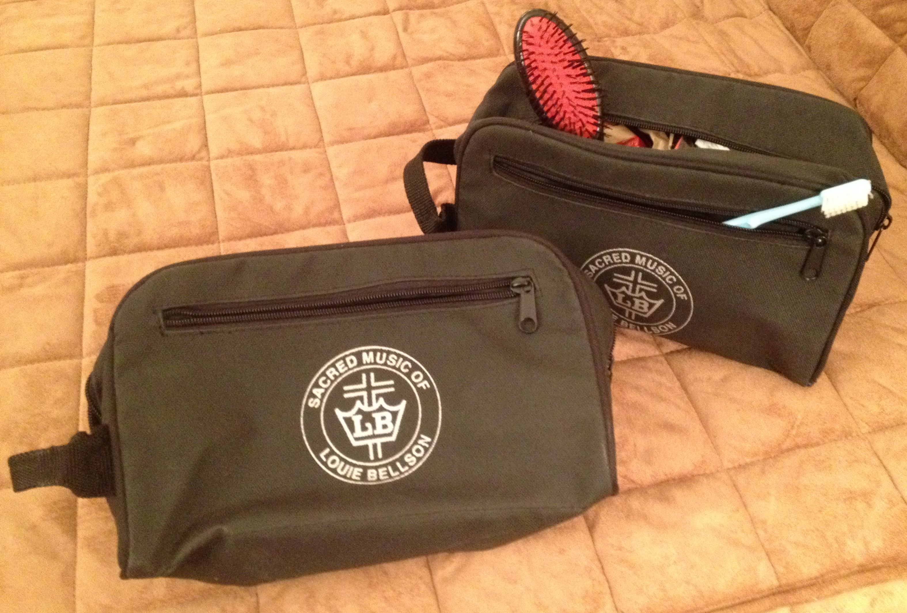 | TOILETRY BAG, men’s  Black w/handle, zipper closure & zipper side pocket  “Sacred Music of Louie Bellson” |  | $20
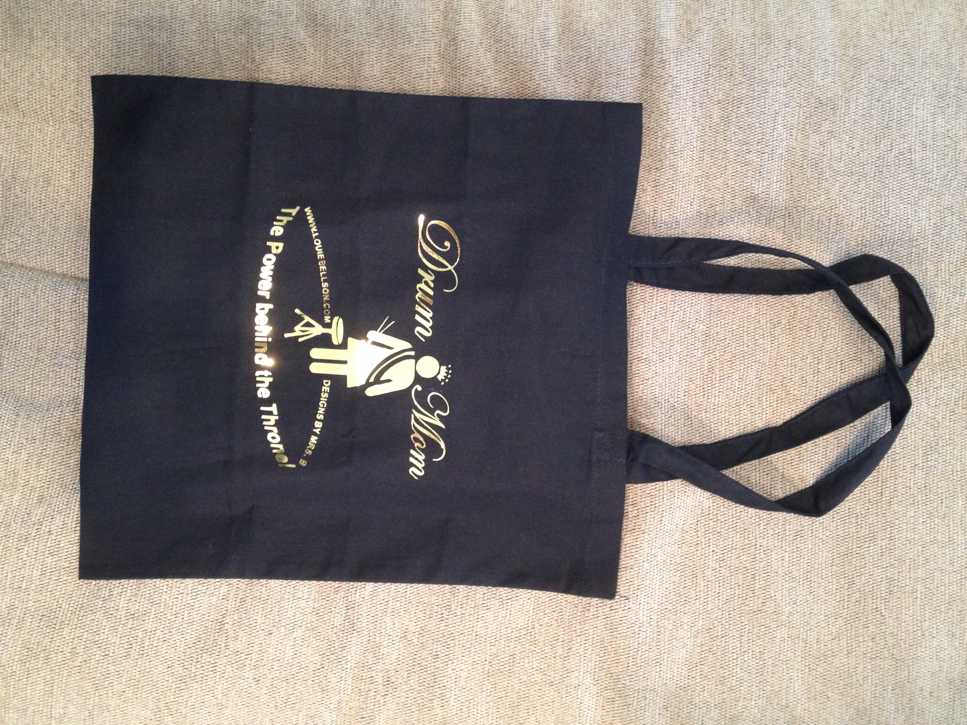  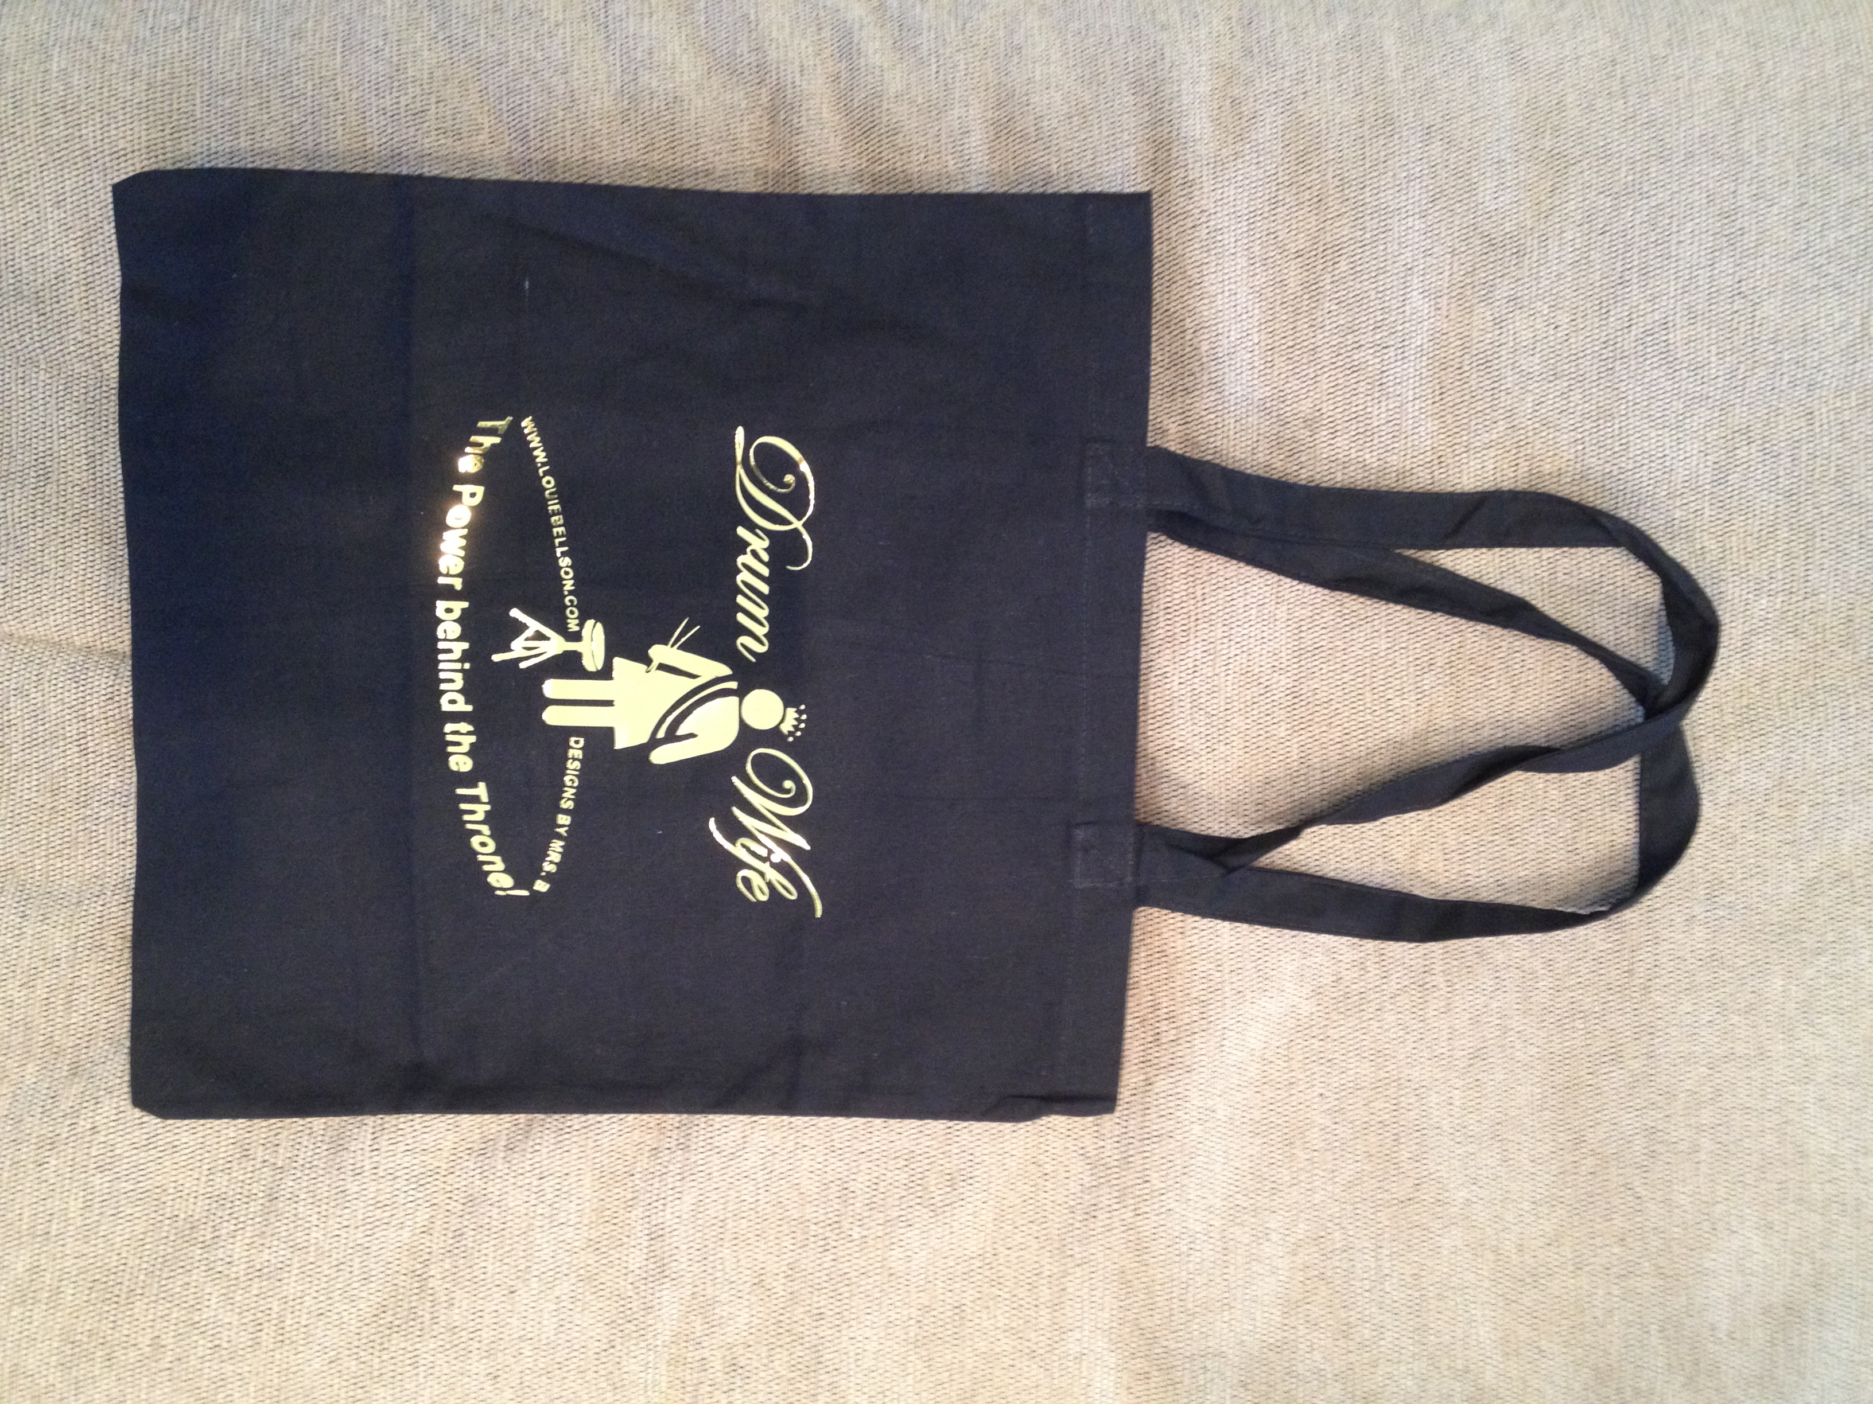 | TOTE BAG: Drum Wife or Drum Mom  16” h x 14.5” w  Gold Foil imprint.  Designed by Mrs. B with a humorous tagline.  __ “Drum Wife”  __“Drum Mom”  (Hurry - only a few left!) |  | $15  $15
 | Total – Page 2 |  |  | $
To Order: Use Worksheet (p. 4)
p. 3

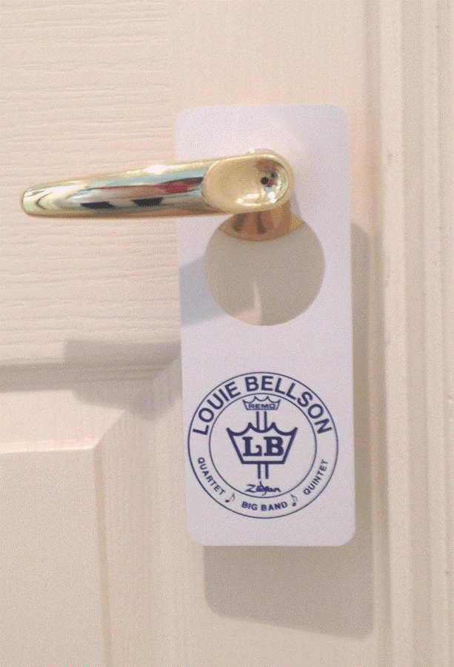
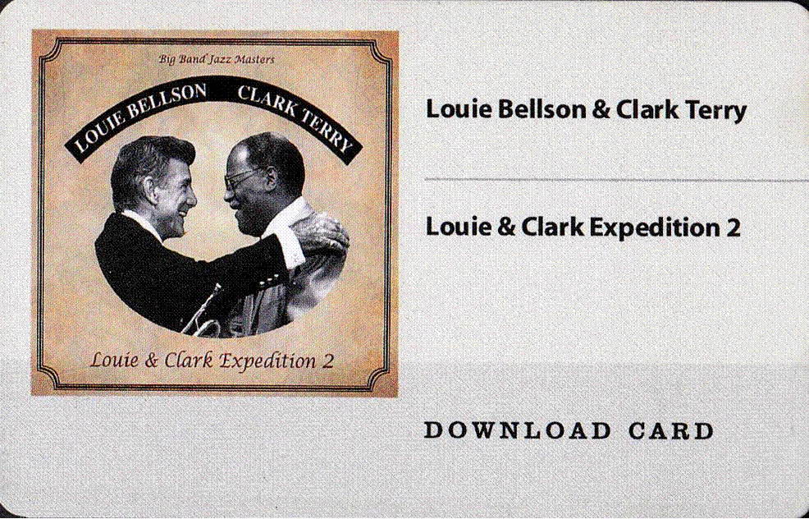
Stick-Tag-Card Combo
- Drumsticks – Zildjian Louie Bellson Artist Series Signature Drumsticks with "Saturn Ring" tip designed by Bellson himself!
- Door Tag – for your practice room. 2-sided, LB logo and humorous sign on reverse.
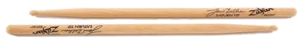
- Download Card – has code to download a full (big-band) album “Louie & Clark Expedition 2”

Play along with an LB album while using LB sticks (& protected by Bellson door tag)!

ITEM | DESCRIPTION | Qty | Price | Amount
↑ see above | STICK-TAG-CARD Combo (3-items) |  | $15
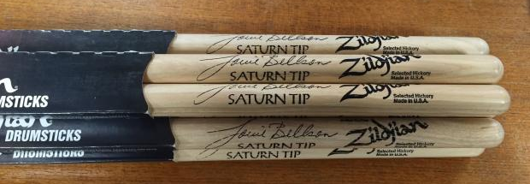  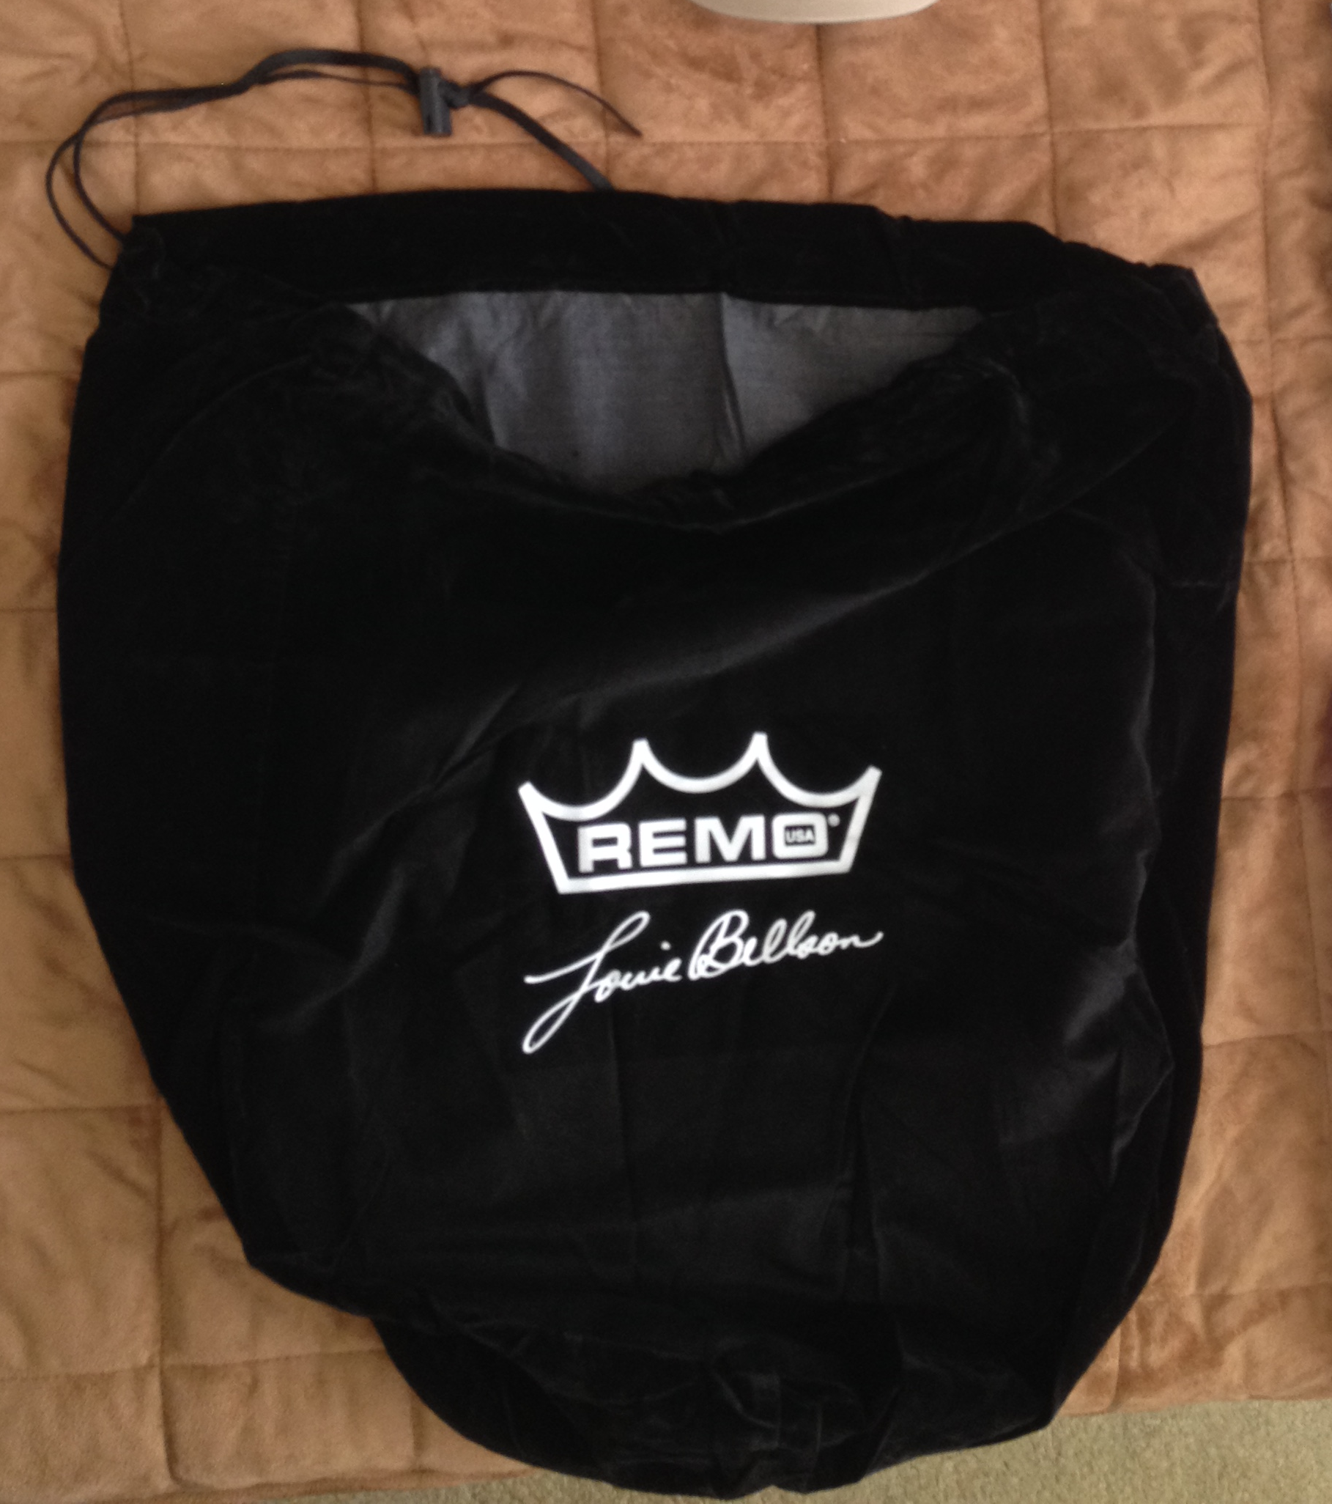 | DRUMSTICK 6-Pack  Teachers & Drummers stock up!  6 pairs of Zildjian Louie Bellson Artist Series Signature Drumsticks  (plus free gifts!) |  | $50
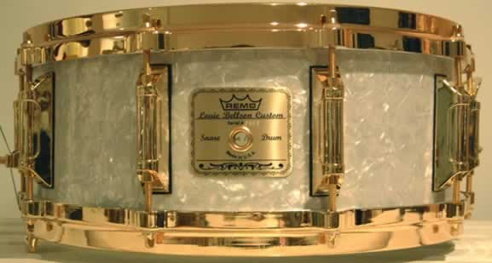 | SNARE DRUM BAG  Drawstring, black velveteen, w/ Bellson signature |  | $20
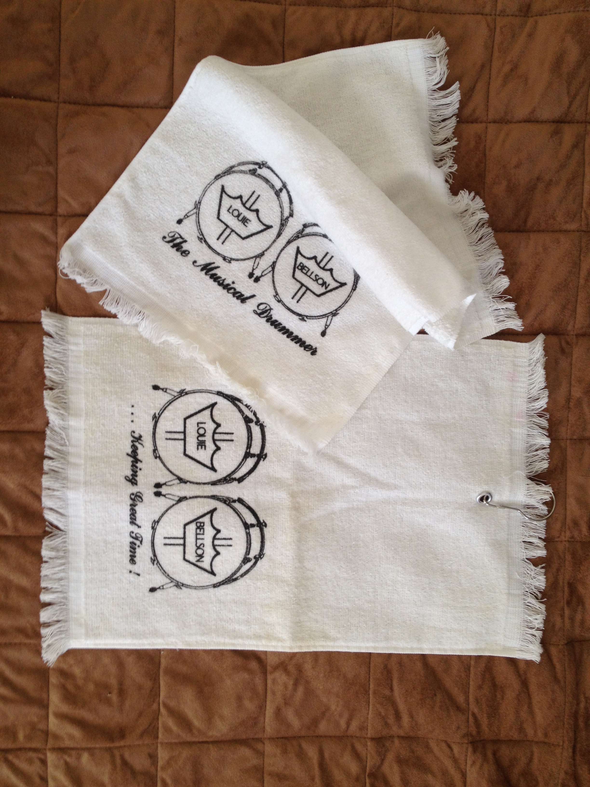 | TOWEL (11”x18”)  __LB “The Musical Drummer”  __LB “Keeping Great Time” (w/ grommet) |  | $10  $10
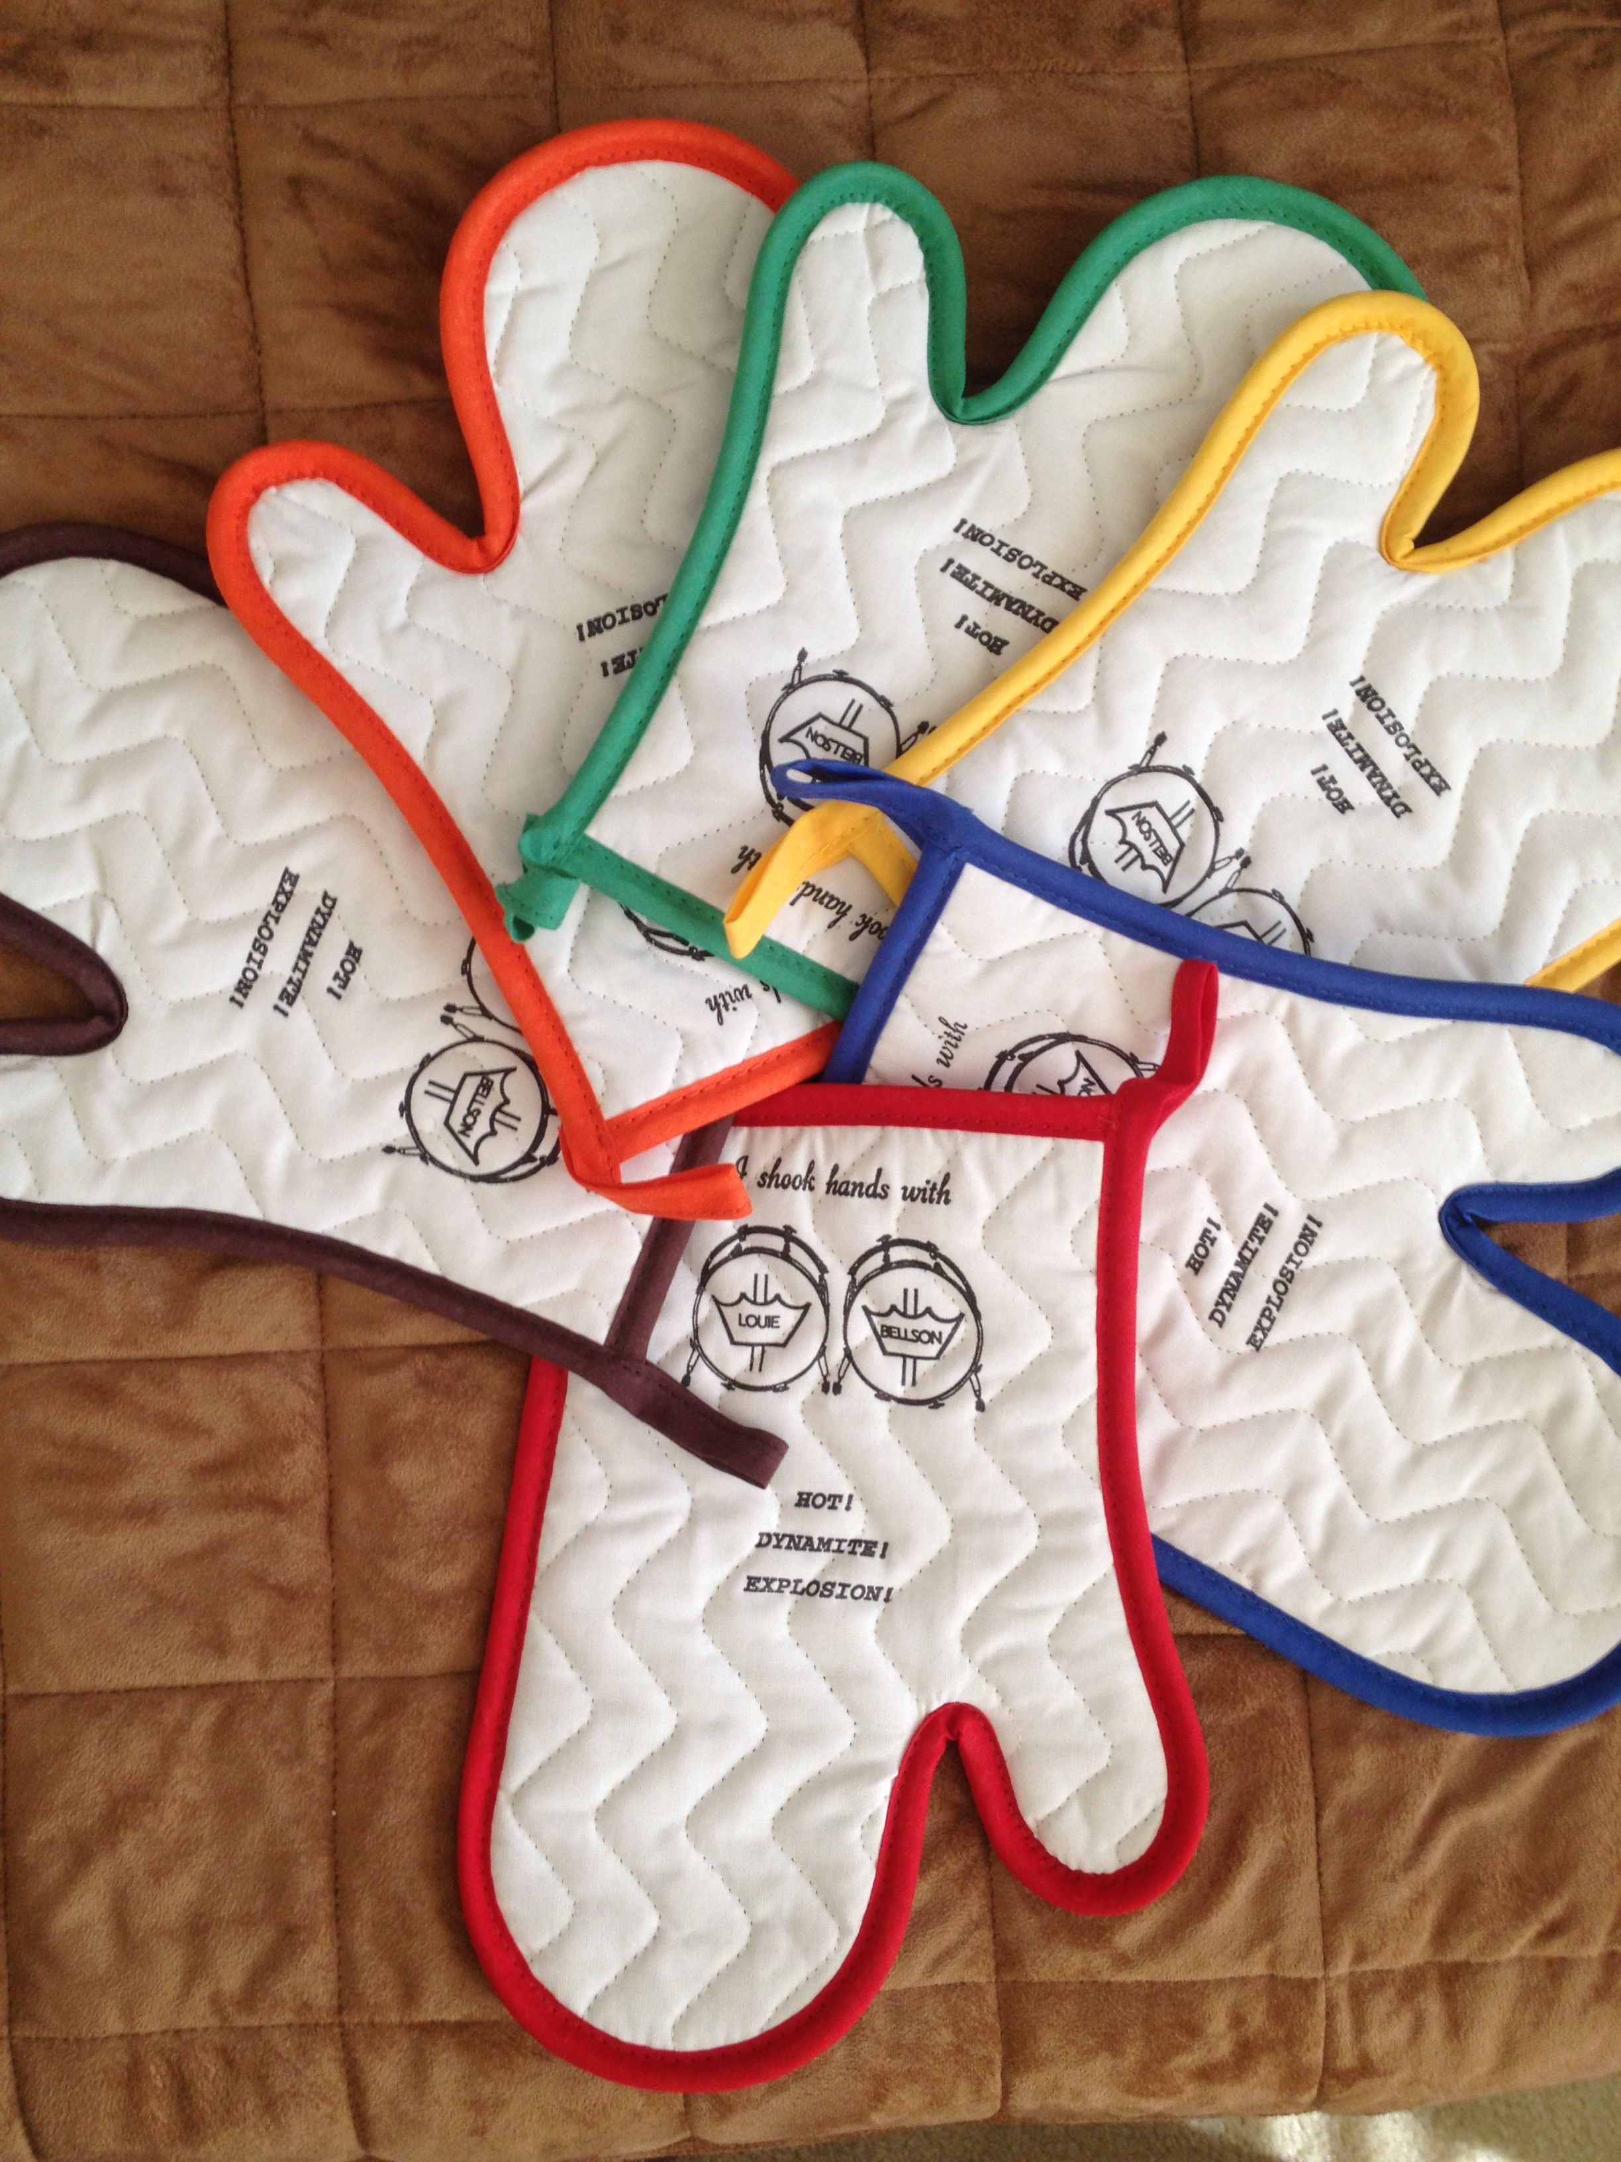 | OVEN MITT  “I shook hands with LB” (w/3 of his “hottest” albums)  Choose trim color:  __Red __Blue __Yellow __Green __Orange __Brown |  | $15
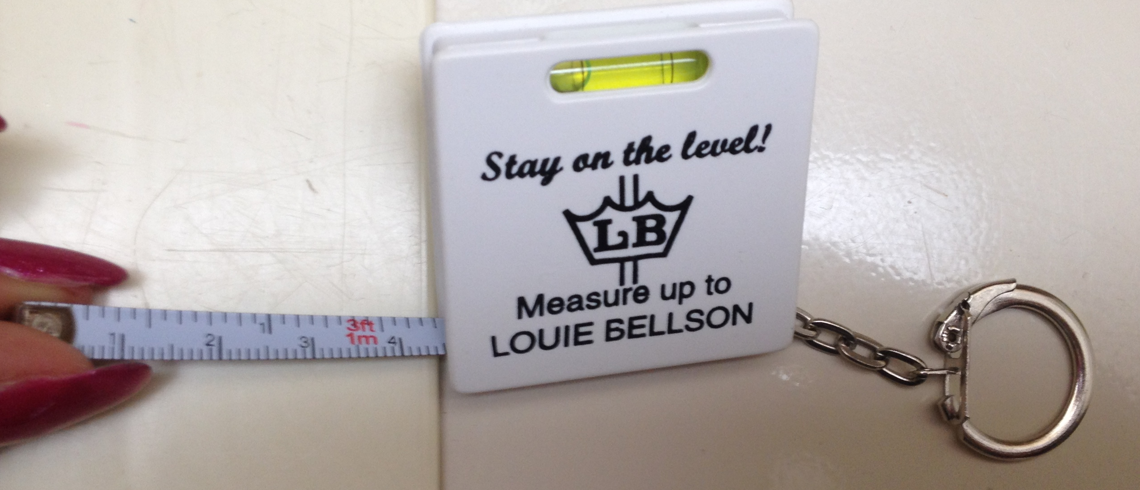 | KEYRING w/Level & Tape measurer |  | $5
 | Total – Page 3 |  |  | $
To Order: Use Worksheet (p. 4)
p. 4

ORDER WORKSHEET
ITEM / Choice (Imprint/Design/Size) | Qty | Price | Amount
 |  | $ | $
 |  | $ | $
 |  | $ | $
 |  | $ | $
 |  | $ | $
MERCHANDISE |  |  | $
PACK & SHIP |  |  | (TBD)
To browse/add more items not listed on this form, go to the SHOPS page of www.louiebellson.com

SUBMIT ORDER

Compose an E-Mail to Mrs. B at bellson_1@att.net
Be sure to include:
- your exact order (items, qty, size, etc.)
- your ship info (city, state, postal code)
Mrs. B will then:
- confirm stock availability
- determine shipping cost.

BILLING

You will receive an email Invoice thru Paypal, which also accepts Credit Cards.

LOUIE BELLSON LEGACY
www.louiebellson.com

Celebrating 90 yrs of Bellson masterworks!
____________________________________________________________________________________
Updated: 12/27/16 Printed: 11/24/26

