BELLSON FUNDRAISING MERCHANDISE

Sell Bellson items to benefit your church, club, school, class or other group.

GUIDELINES:
1. CDs (Label: Percussion Power only). Wholesale/Retail, $10/$20. Your group’s profit: $10 per CD.
2. LAPEL PINs Wholesale/Retail, $2/$5. Your group’s profit: $3 per pin.
3. *Minimum Order Quantity: 20 items (total).
4. Billing: Must be prepaid. By check only. No returns.

www.louiebellson.com
bellson_1@att.net


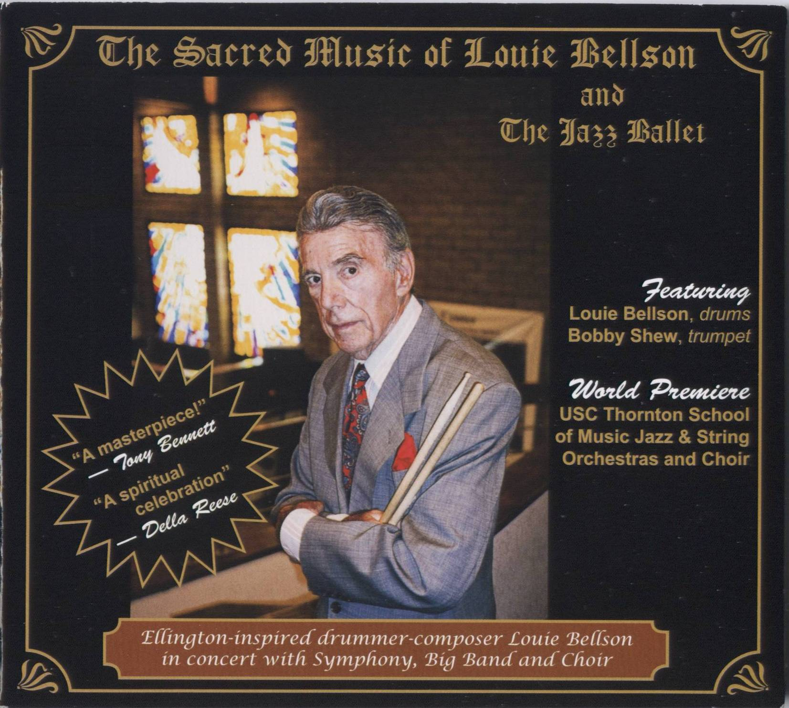
CD: “The Sacred Music of Louie Bellson”
Ellington-inspired drummer-composer Louie Bellson wrote and performed in concert with Symphony, Big Band and Choir. Musicians include USC Orchestras and Bobby Shew.
CD: “Louie & Clark Expedition 2”
Jazz masters Louie Bellson (drums) and Clark Terry (trumpet) join on this dynamic album of new big band music written by composer Bellson.
Also features Kenny Washington and Sylvia Cuenca (drums).

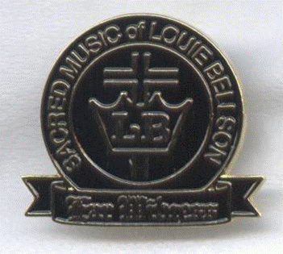

LAPEL PIN: Sacred Music
black & gold, 1" x 7/8"
Inscribed:
“Sacred Music of Louie Bellson – Ear Witness."

BELLSON FUNDRAISING MERCHANDISE - ORDER FORM
(Copy page for your records.)
ITEM | *Qty | Wholesale  Price | AMOUNT
CD:  The Sacred Music of Louie Bellson | __ | $ 10 | $
CD:  Louie & Clark Expedition 2 | __ | $ 10 | $
LAPEL PIN:  Sacred Music | __ | $ 2 | $
*Min. Qty: 20 items (total) SUB-TOTAL: | __ |  | $
Shipping: |  |  | $ 10.00
Ck. #_______ TOTAL ENCLOSED: |  |  | $
Mail this form with check payable to:
FRANCINE BELLSON
Louie Bellson Legacy
4848 San Felipe Rd. #150-610
San Jose, CA 95135
OR, contact Mrs. Bellson at bellson_1@att.net with your credit card/Paypal info.

Contact Person___________________________________________________
Name of Organization_____________________________________________
Shipping Address_________________________________________________
_______________________________________________________________

_______________________________________________________________
E-mail__________________________________________________________

Phone______________________________

